# Two-tier Application Deployment on AWS EKS

Follow these steps to deploy the application on AWS EKS.

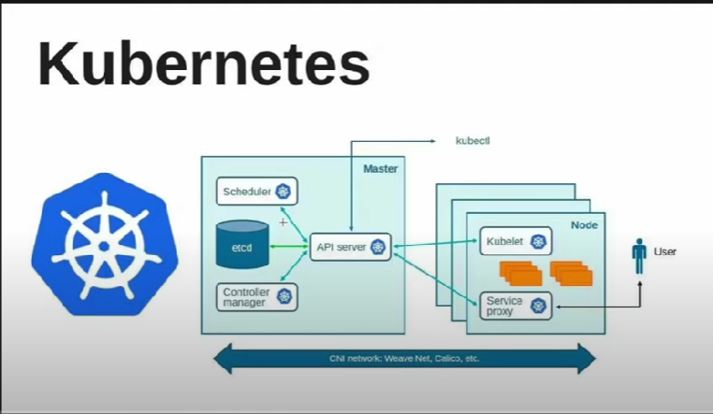

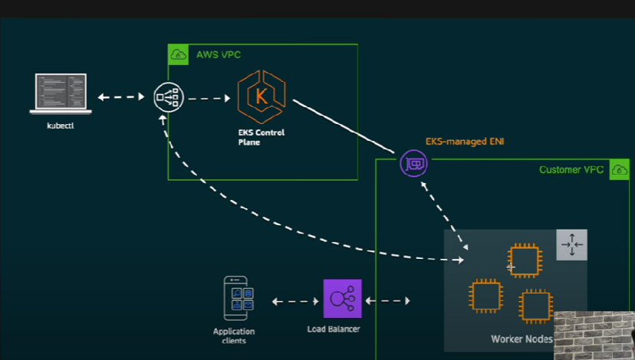

1. create a new ec2 instance - eksentrypointnew

2. connect to ssh using gitbash

3. sudo apt update

4.

Install AWS CLI v2

curl "https://awscli.amazonaws.com/awscli-exe-linux-x86_64.zip" -o "awscliv2.zip"

sudo apt install unzip

unzip awscliv2.zip

sudo ./aws/install -i /usr/local/aws-cli -b /usr/local/bin --update

check version

aws --version

5. create user

I AM

eks-admin-new

next - attach policy

adminstrative access

security credentials

access keys

command line interface

download

6. aws configure

7. aws s3 ls

8. Install kubectl

curl -o kubectl https://amazon-eks.s3.us-west-2.amazonaws.com/1.19.6/2021-01-05/bin/linux/amd64/kubectl

chmod +x ./kubectl

sudo mv ./kubectl /usr/local/bin

kubectl version --short --client

kubectl version

9. install eksctl

https://github.com/eksctl-io/eksctl

# for ARM systems, set ARCH to: `arm64`, `armv6` or `armv7`

ARCH=amd64

PLATFORM=$(uname -s)_$ARCH

curl -sLO "https://github.com/eksctl-io/eksctl/releases/latest/download/eksctl_$PLATFORM.tar.gz"

# (Optional) Verify checksum

curl -sL "https://github.com/eksctl-io/eksctl/releases/latest/download/eksctl_checksums.txt" | grep $PLATFORM | sha256sum --check

tar -xzf eksctl_$PLATFORM.tar.gz -C /tmp && rm eksctl_$PLATFORM.tar.gz

sudo mv /tmp/eksctl /usr/local/bin

## eksctl version

10. create cluster.

eksctl create cluster --name tws-cluster-new --region ap-south-1 --node-type t2.micro --nodes-min 2 --nodes-max 3

kubectl get nodes

encoding password

echo -n "admin: | base64

https://github.com/LondheShubham153/two-tier-flask-apps

https://github.com/LondheShubham153/two-tier-flask-app.git

cd two-tier-flask-app

cd eks-manifest

kubectl apply -f mysql-secrets.yml -f mysql-configmap.yml -f mysql-deployment.yml -f mysql-svc.yml

kubectl apply -f two-tier-app-deployment.yml -f two-tier-app-svc.yml

kubectl get all

kubectl describe pods

kubectl get svc